BIOE 301C Lab 1

1. mA vs. Dose is linear.

kV vs. Dose is not linear.

Ln(dose) vs ln(kV) is linear.

n with absorber is greater than n without absorber. This means that if there is an absorber present, there are greater differences in the number of transmitted photons per increase in kV.

1. Acrylic:

–u_eff=-0.2882 at 60kV

-u_eff=-0.2152 at 120kV

Copper:

-u_eff=-3.8761 at 60kV

-u_eff=-1.4332 at 120kV

The effective attenuation coefficient for copper is greater than that for acrylic. The effective attenuation coefficient is less for higher electrostatic potentials.

1. The increase in dose that corresponds to the increase in field size (when the dose should actually not increase) is due to the photons that scatter from the detector and hit the ion chamber. As the field size increases, the amount of detector that the photons can hit and scatter increases. Thus, we see the increase in dose.

0mm Acrylic: 3.214mGy

6.6mm Acrylic: 585uGy

12.12mm Acrylic: 101uGy

S/P increases with increasing field size and with increasing object thickness.

(The ratio of S25/P is not quite valid because of the negative integer. However, this is simply due to the line of best fit. I think that setting S25 equal to a value =1 would be a close comparison to the real ratio and would give a positive ratio value.

1. All done in Matlab
2. Step Profile without log processing:

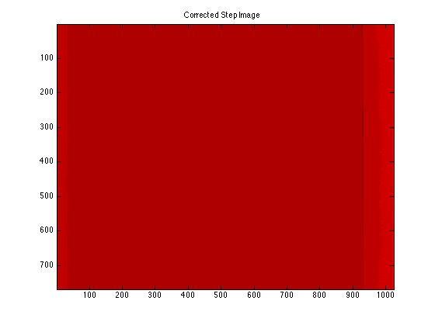

What are the axes labels?

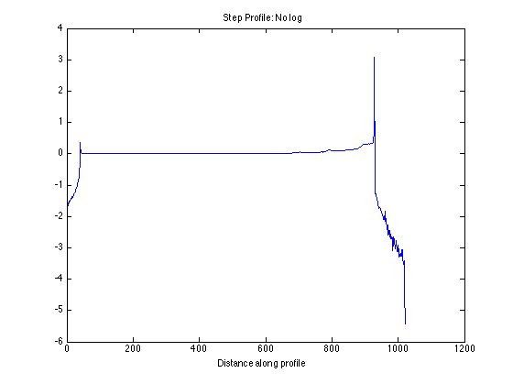

Step Profile with log processing: (obviously necessary)

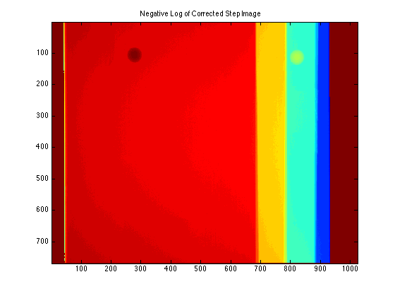

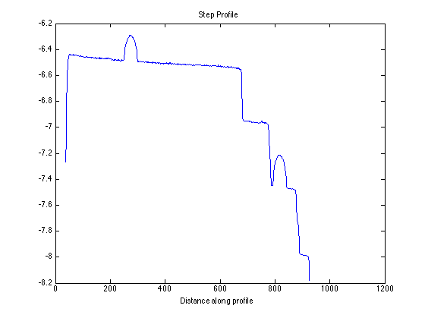

We can now see the steps nicely resolved. Each spherical contrast target has a difference in intensity of about 0.2 units. The difference in contrast might be slightly greater for that on the right, with a smaller acrylic thickness.

Log processing is obviously necessary to tease out the differences in contrast. What exactly is it doing?